- Look at the picture. Answer the question. Write a complete sentence.

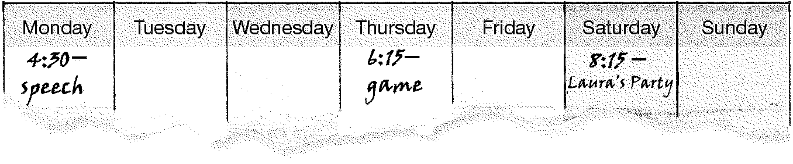
Example: What day is the game?
It’s on Thursday .



- What time is it?
________________________________________.

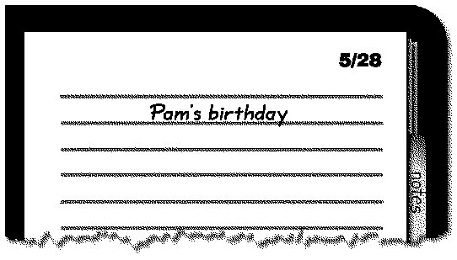

- When is Pam’s birthday?
________________________________________.

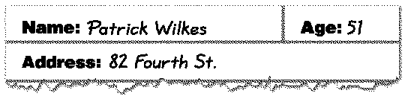

- How old is Patrick?
________________________________________.

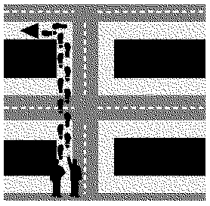

- How do I get to the taxi stand?
________________________________________.

- Complete the sentence. Circle the correct word or phrase.
Example:
- Where (is / am / are) the pictures?
- Anna (need / want / needs) a lawyer.
- (Don’t / Isn’t / Not) walk to the stadium. Take the bus.
- How many chairs (are / do / isn’t) there in the dining room?
- (Does / Do / Are) they like their new house?
- Rebecca (doesn’t / don’t / do) want a blouse.
- There (do / is / are) two convenience stores near here.
- She (like / have / has) that sweater in green.
- Do you (have / has / don’t have) a microwave in your kitchen?
- When (is / has / does) the concert?
- What (are / is / do) your name?
- What (are / is / have) your parents’ occupations?

- Complete the sentence. Choose the correct answer.
Example: a | The movie is at 7:40. Let’s meet _____ 7:20.  - at b. in c. on

- Hi, I’m _____ Nixon. This is my husband, Mark.
a. Mrs. c. Mr.
b. Miss

- Her apartment is _____ the ninth floor.
a. in c. on
b. at

- We live in _____.
a. Grand Avenue c. 52 Main Street
b. Mexico City

- John is Marie’s son. Marie is _____ mother.
a. his c. my
b. hers

- My birthday is _____ March.
a. on c. at
b. in
- It’s 10:15. The speech is at 11:00. I’m _____.
a. early c. late
b. on time

- The furniture is in my _____ house.
a. grandmother’s c. her
b. grandmother

- Janie and Mike have two children. _____ names are Kelly and Brian.
a. Your c. Our
b. Their

- The party is _____ Tuesday, April 19.
a. in c. on
b. at

- I like _____ rug near the sofa.
a. those c. that
b. these

- Read the group of words. Cross out the word or phrase that is different.

Example:
architect |  |  |  |  |  |  | mall |  |  |  |  |  | post office |  |  |  |  |  |  |  |  |  |  | pharmacy
microwave |  |  |  |  |  |  |  |  | stove |  |  |  |  |  |  |  |  | factory |  |  |  |  |  |  |  |  |  |  |  | refrigerator
bus | train |  |  |  |  |  |  |  |  | taxi |  |  |  |  |  |  |  |  | pilot
dresser |  |  |  |  | sweater |  |  |  |  |  |  |  |  |  | blouse |  |  |  |  |  |  |  | jacket
sister |  |  |  | grandmother |  |  |  |  |  |  |  |  |  |  |  | daughter |  |  |  |  |  |  |  |  |  |  |  |  | neighbor
across the street |  |  |  |  |  |  |  |  |  |  | around the corner |  |  |  |  |  |  |  |  |  |  |  |  |  |  | walk |  |  |  |  |  |  |  | on the right
July |  |  | Monday |  |  |  |  |  |  |  |  |  |  | September |  |  |  |  |  |  |  |  |  |  |  |  |  | January
play |  | speech |  |  |  |  |  |  |  |  |  | party |  |  |  |  |  |  |  |  | stadium
colleague |  |  |  |  |  | singer |  |  |  |  |  |  |  |  | boss |  |  |  |  |  |  | classmate
sink |  |  |  | upstairs |  |  |  |  |  |  |  |  | bathtub |  |  |  |  |  |  | shower
handsome |  |  |  |  |  |  |  | ugly |  |  |  |  |  |  |  |  | pretty |  |  |  |  |  |  |  | good-looking

- Read the newsletter. Then read the sentences. Write J if the sentence is about Jessica. Write A if the sentence is about Allison. Write JA if the sentence is about Jessica and Allison.

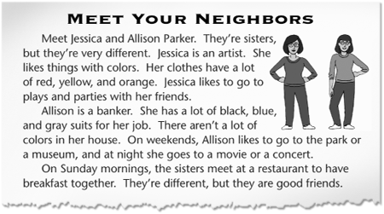
Example: She likes blue and black clothes. A
- She likes the park and the movies. ________
- She likes a lot of colors. ________
- She goes to a restaurant on Sundays. ________
- She works in a bank. ________
- She is different from her sister. ________

Read the article again. Then answer the questions.
Example: Who is Jessica’s sister? Allison
- What is Jessica’s job?
_________________________________________________________________
- What does Allison wear to work?
_________________________________________________________________
- When do the sisters eat together?
_________________________________________________________________

- What would you say? Complete the conversation.

1) "Are you a doctor?"
 | __________________________________________________________.

2) "Hi. I’m Eduardo Andrade."
__________________________________________________________.

3) "How are you?"
________________________________________________________

