Hip Hip Hooray 4 Unit 5-8

Fill out the correct possessive pronoun!

1. I have a dog. That dog is________!
2. She has a cat. That cat is ________!
3. We have a car. That car is ________!
4. They have a bike. That bike is ________!
5. He has a key. That key is ________!
6. You have a hat. That hat is ________!
Choose the best option.
- I can't see Mary. I can't see ________
- Him b. she c. her
- Karen is next to Peter. Karen is next to ________
- He b. him c. he
- _________ did she get to school?
- Which b. How c. Whose
- Can you help Peter and Ann? Can you help ________?
- They b. you c. them
- Drink your apple juice! Drink ________!
- it b. its b. your
- _________do we do now? We find a teacher.
- Which b. What C. How
- We are going to the cinema. Come with ________!
- we b. them c. us
- What do we __________? We find a teacher.
- found b. finding c. do d. doing

Complete the sentences with correct form of the words.
- She’s ___________( friendly) than Jim.
- What happened? She ____________(make) a mess.
- Did he ________(ride) the scooter.
- Why are you ___________(worry)? Because I __________(forget) my homework.

Read and fill in the blanks with given words.
Bigger boy friend play old went

Tom is a very little ______________. He is eight years ______________.
Tom's ______________ is Lucy. She is a lot ______________ than Tom.
They usually ______________ in the park after school. Yesterday they
______________ to the mall.

Answer the following questions.

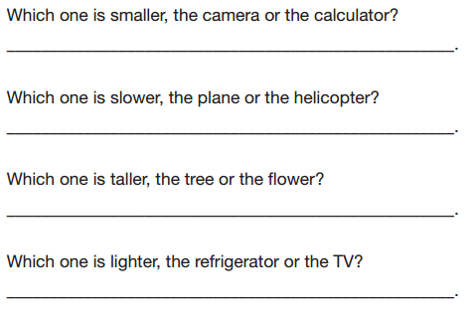

Circle the correct words.
1 I scored a goal.
We cheered loudly / loud / good.
2 Her worked is good.
She works badly / well / quickly.
3 He ran slowly. He didn’t win the race.
He ran fast / didn’t run fast / ran well.
4 They scored 10/10 in the exam.
They did badly / well / good.

Complete the description of Joe’s bus journey to school.
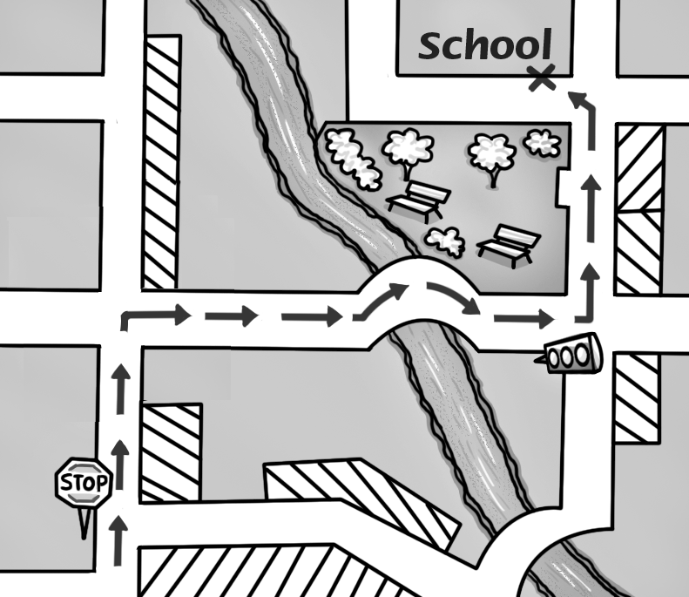
I go to school by bus. Every morning I get the bus outside my house. The bus ¹ ______________ . We ² and we go over the bridge and we go past the park. At the ³ we ⁴ . The school is ⁵ .

Read. Answer the questions.

Tom is at Lucy's house. Yesterday they played soccer.
Today they are going to play basketball.
"Wait," says Lucy. "I have to take out the garbage."
Tom waits for Lucy.
1. Where is Tom?
______________________________________________________.
2. What are they going to do today?
______________________________________________________.
3. What did they do yesterday?
______________________________________________________.
4. What does Lucy have to do?
______________________________________________________.

