Tiny talk 1B
Unit 6-8

A) Find " star "? circle. (3)

B) Match.(3)
- 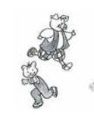 * Let’s slide
- 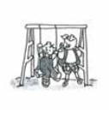 * Let’s run
- 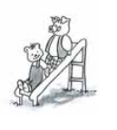 * Let’s Swing

C) Color the correct answer. (3)
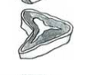
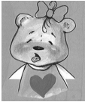
I like bread

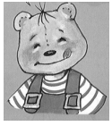
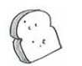

I like meet

D) Match. (4)
- Daddy 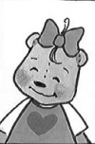
- Mammy 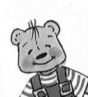

- Brother 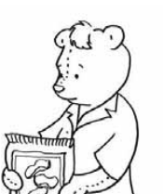

- Sister 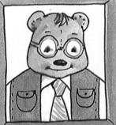

E ) Write the correct number for each picture.(3)
- I’m home
- Daddy’s home.
- He’s my daddy.
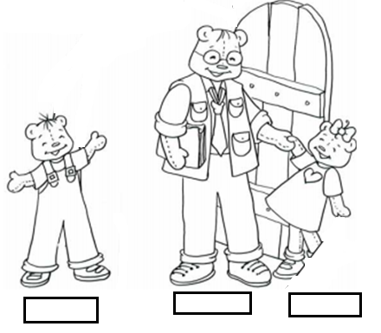

I) Match (4)
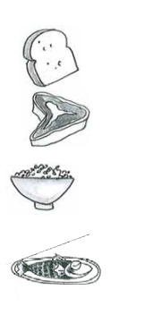
- Rice
- Fish
- Bread
- Meat

GOOD LUCK

