Top notch 3B (Unit6-7-8-9-10)
Choose the best answer for each question.
- Is it a page-turner?
- Did she think the book was hard to follow?
- Did he finish reading that book?
- Is it a cliffhanger?
- Was that novel a bestseller?
- Is it a fast read?
- Do you know where this memoir takes place?
- Do you know where I could find a good thriller?

- Yes! It's so exciting and keeps you guessing right until the end.
- No, hardly any copies of it were sold.
- Yes! It really makes you want to keep reading.
- I thought he had finished it.
- Look in the action / adventure section over there.
- Yes, I believe she thought the book was difficult to understand.
- In England, during the Victorian era.
- Oh yeah, it only took me an hour to read the whole book.

Choose the correct word for each picture.

  - a landslide
  - a typhoon
  - a drought
  - a tornado
  - a flood
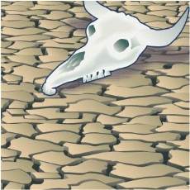
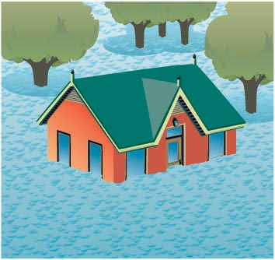
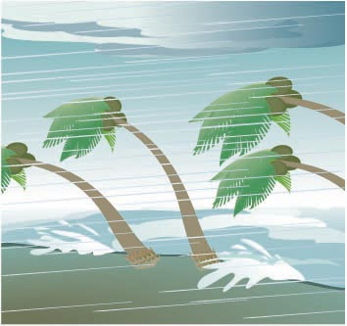
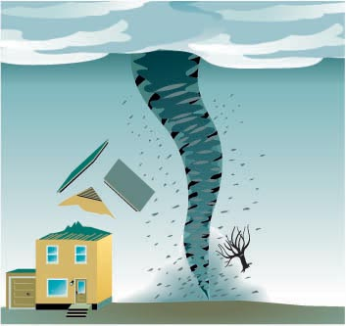
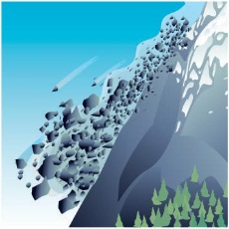
- 2. 3. 4. 5.

Choose the sentence that can describe the question in the best way.
- If I hadn't missed the bus, I would've been on time.
  - I missed the bus and I was on time.
  - I missed the bus and I was late.
  - I didn't miss the bus and I was on time.

- If I had enough money, I'd buy a state-of-the-art laptop.
  - I had enough money to buy a state-of-the-art laptop, and I bought one.
  - When I have enough money to buy a state-of-the-art laptop, I'll buy one.
  - I don't have enough money to buy a state-of-the-art laptop, but I wish I did.

- Could you have done a better job if you had had more time?
  - Could you do a better job if I gave you more time?
  - Do you think you would have done a better job if you had more time?
  - Did you do a better job when you had more time?

- If you hadn't forgotten your cell phone, you could've called me.
  - You had your cell phone, so you could've called me.
  - You forgot your cell phone, but still should've called me.
  - You forgot your cell phone, so you couldn't call me.

- I'd love to buy a high-end car with state-of-the-art technology.
  - I'd love to buy an efficient car with innovative technology.
  - I'd love to buy a first-rate car with cutting-edge technology.
  - I'd love to buy a novel car with unique technology.

- Where have you been?
  - How could you have not known?
  - Where were you?
  - What took you so long?

- No way! I don't believe it.
  - I don't believe that's true.
  - I'm very surprised to hear that.
  - That's not possible.

Match phrases to complete a sentence.(one option is additional)
- Are you going to advise
- The solution to the problem of corruption doesn't seem
- Corruption of government officials appears
- The presidential candidate reminded
- The belief that some groups are inferior to others causes

  - the mayor to speak on the new testing program.
  - to help at the community health center.
  - to be a terrible problem all over the world.
  - to prohibit smoking indoors.
  - voters to support the party's program.
  - racism and ethnic discrimination to exist.

Choose the best item for each question.
- A: I think censorship of books and movies is a very serious problem.
B: ___. I think the increase in terrorism is much more serious.

  - I tend to be a little opinionated
  - I'm afraid I don't agree
  - That's exactly what I think
- A: I'm in favor of compulsory military service. What about you?
B: ___.
  - I agree with you on that one
  - That's one way to look at it
  - If you know someone well, it's OK

- A: The liberal candidate seems to offer the best education program.
B: ___. The conservative candidate presents a much stronger program.
  - I couldn't agree more
  - It's OK under some circumstances
  - I have to disagree with you there

- A: Is it OK to discuss politics at dinner?
B: ___.
  - That depends
  - I couldn't have said it better myself
  - I'm not sure I agree
- A: I think we should raise the voting age.
B: ___? I'm not sure I agree.
  - Are you in favor of raising the voting age
  - Do you really think so
  - What about you

- A: I think it's wrong to take a life, no matter what.
B: ___.

  - I'm in favor of capital punishment too
  - How well you know me
  - I couldn't agree more

- A: It's not cool to discuss controversial topics with people you don't know well.
B: ___. But on the other hand, it can be interesting.

  - On the one hand, I agree
  - Yes, I am
  - I tend to be a little opinionated

- A: That may be true, but I think it's wrong.
B: ___.
  - I express my beliefs strongly
  - We'll have to agree to disagree
  - No matter what

- A: What's your opinion about censorship?
B: ___.
  - That may be true
  - That's exactly what I think
  - It's wrong no matter what

- A: Would it be OK to ask you about the election?
B: Sure. ___?
Are you in favor of the moderate candidate
  - What would you like to know
  - Do you agree with me on that one

Complete the conversation. Use words from the box.

Dangerous dark exhausting foggy
Mountainous rocky slippery steep

Jack: I can't wait to go hiking in the Andes mountains. I hear the views are spectacular.
Colin: They are breathtaking. Have you done much hiking before?
Jack: No. This will be my first time, actually.
Colin: Well, hiking in the Andes can be quite ……………………… so you should be careful.
Jack: Thanks for the warning, but what's unsafe about it?
Colin: Well, any time you go hiking in a ……………………… area, such as the Andes, there are possible risks you should know about.
Jack: Really, like what?
Colin: Well, many of the paths up into the mountains can be extremely……………………… . At some points, you may even need to use your hands to pull yourself up as you climb.
Jack: Sounds like quite a workout.
Colin: Yes, actually, it can be terribly . ………………………
Jack: That's OK. Anything else I should know?
Colin: Yes. Many times, paths can be very ……………………… so you must be careful not to trip over any loose rocks or pebbles. And if it rains, the paths can be even more . ………………………
Jack: OK. I can handle that.
Colin: Also, try not to go hiking too late in the day. At night, it can get too……………………… to see anything. Also, it can be really ……………………… in the mornings when you're higher up the mountains. That can make it hard to see even during the day.
Jake: Thanks for all the advice.

Complete the conversation. Type in, on, or of.

A: Do you know how to get to June's house?
B: What town does she live…………. again?
A: …………. Belle Mead, …………. central New Jersey.
B: Oh, OK. That's the town right…………. the border Princeton, right?
A: Yes, that's right. It's just north …………. there.
B: Well, that's right off Route 1.
A: OK. How do I get to Route 1?
B: Well, after you go across the bridge, get …………. the Turnpike going South.
Take Exit 9 off the Turnpike. After you pay the toll, you'll need to take
the first exit…………. the right.
A: OK, got it. Then what?
B: You get to a point where two roads merge together. Make sure you
are …………. the left lane. Keep following the signs for Route 1 South. Take Route 1

until you get to Finnegan Lane. Make a right. After about a mile, you'll see a sign

with a bicycle on it …………. your left. Turn left at the next corner and you're there.
A: OK, great. Thanks!

Choose the best definition for each word.

1 an evacuation
2 a shelter
3 a first-aid kit
4 a power outage
5 non-perishable food
6 a flashlight

- food that doesn't need refrigeration, such as canned foods and dried foods
- an interruption in the flow of electricity over a large area
- a safe place where people may go when the area they live in has been evacuated
- a small box containing supplies to treat minor illnesses and injuries
- a portable, battery-operated light
- the removal of all people from an area or neighborhood that is too dangerous

